Assignment 11  
Chaiwat Plongkaew 2021326660023

P12. Describe how loops in paths can be detected in BGP.

Ans

The loops in the BGP (Border Gateway Protocol) can be detected as follows:

* The BGP protocol propagates and obtains reachability of all the neighboring AS (Autonomous Systems).
* The attributes AS-PATH and NEXT-HOP are used for routing.
* The router verifies all the AS numbers. If it finds its own number, it will discard the advertisement to prevent looping. In this way, BGP detects the loops and prevents them.

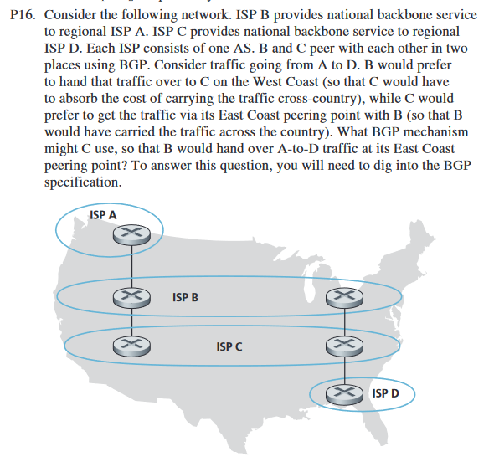

Ans

Given:  
ISP B provides the national backbone to the regional ISP A.  
ISP C provides the national backbone to the regional ISP D.  
Each of the ISP consists of one autonomous systems (AS).

ISP B would like to hand over the traffic of C through the West Coast

ISP C would like to receive traffic from B’s peering point via East Coast.

One way for C to force B to hand over all of B’s traffic to D on the east coast is for C to only advertise its route to D via its east coast peering point with C.

P20. Suppose ASs X and Z are not directly connected but instead are connected by AS Y. Further suppose that X has a peering agreement with Y, and that Y has a peering agreement with Z. Finally, suppose that Z wants to transit all of Y’s traffic but does not want to transit X’s traffic. Does BGP allow Z to implement this policy?

Ans

Yes, BGP allows Z to implement policy.

Given data:

The network contains Autonomous Systems AS X, AS Y, and AS Z.  
BGP means Border Gateway Protocol. It is an Inter-AS routing protocol.

• It takes the subnet reachability data from neighboring AS.

• AS X has an agreement of peering with AS Y.

• AS Y has an agreement of peering with AS Z.

• This protocol permits AS Z to develop the policy.

• The *BGP* route trailers are held by each AS.

• AS Y should present AS X that, it has no path to Z.

• The system AS X is ignorant that AS Y has a path to AS Z.

• AS X never forwards the traffic.

• AS Z can transfer all of Y’s traffic.

P22. In Section 5.7, we saw that it was preferable to transport SNMP messages in unreliable UDP datagrams. Why do you think the designers of SNMP chose UDP rather than TCP as the transport protocol of choice for SNMP?

Ans

The reason is that, if the SNMP protocol runs over the TCP, then stops sending messages. If the network manager wants to send SNMP messages, then the control of TCP is backed off to SNMP.